**Single Light Sensor**

// C++ code

//

void setup()

{

pinMode(4,OUTPUT);

}

void loop()

{

digitalWrite(4,HIGH);

delay(1000); // Wait for 1000 millisecond(s)

digitalWrite(4,LOW);

delay(1000); // Wait for 1000 millisecond(s)

}

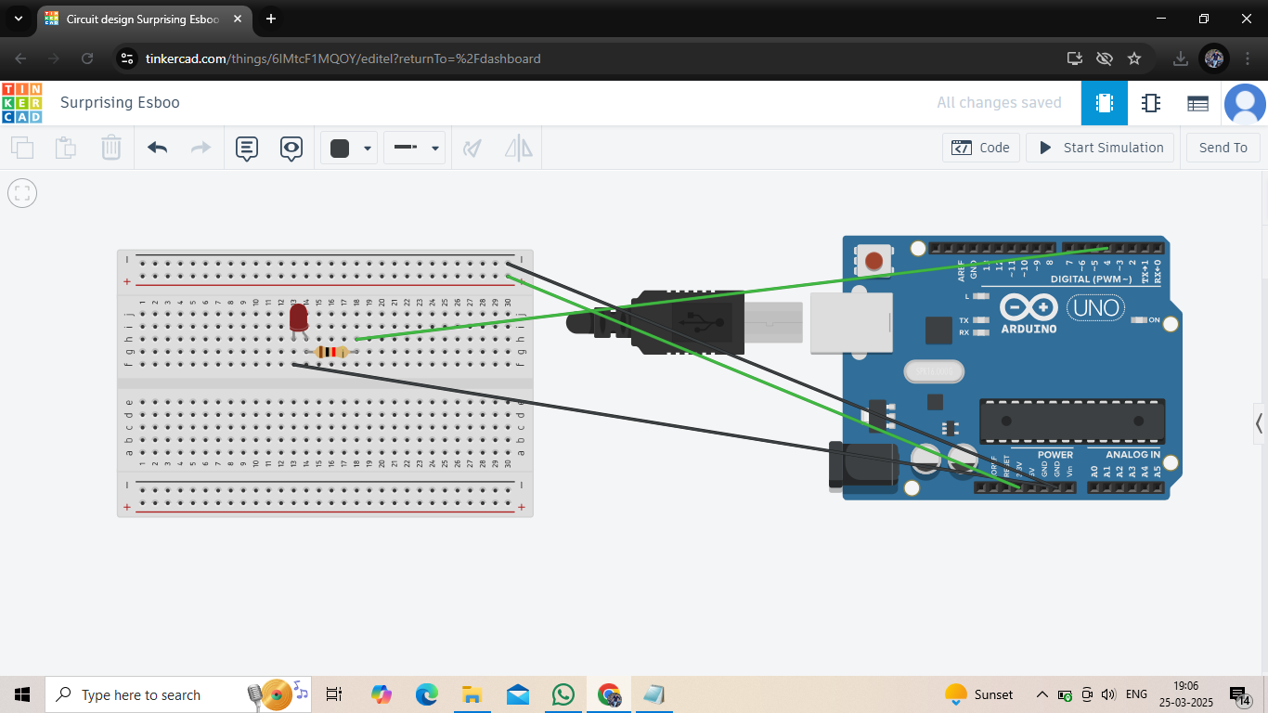

**Double Light Sensor**

// C++ code

//

void setup()

{

pinMode(7,OUTPUT);

pinMode(8,OUTPUT);

}

void loop()

{

digitalWrite(7,HIGH);

digitalWrite(8,HIGH);

delay(1000); // Wait for 1000 millisecond(s)

digitalWrite(7,LOW);

digitalWrite(8,LOW);

delay(1000); // Wait for 1000 millisecond(s)

}

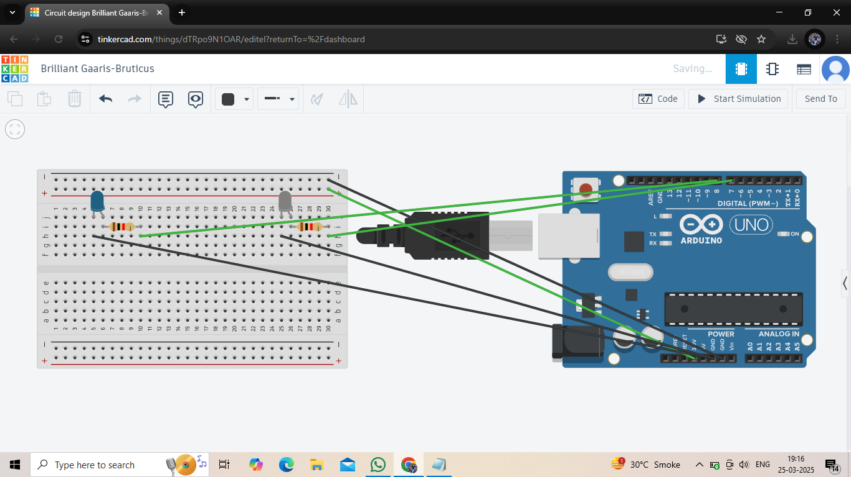

**Traffic Light Sensor**

// C++ code

//

void setup()

{

pinMode(4,OUTPUT);

pinMode(7,OUTPUT);

pinMode(8,OUTPUT);

}

void loop()

{

digitalWrite(4,HIGH);

digitalWrite(7,HIGH);

digitalWrite(8,HIGH);

delay(1000); // Wait for 1000 millisecond(s)

digitalWrite(4,LOW);

digitalWrite(7,LOW);

digitalWrite(8,LOW);

delay(1000); // Wait for 1000 millisecond(s)

}

